**DAILY ONLINE ACTIVITIES SUMMARY**

|  |  |  |  |
| --- | --- | --- | --- |
| **Date:** | 21/05/2020 | **Name:** | Krishnitha |
| **Sem & Sec** | 4th sem, A Section | **USN:** | 4AL18CS039 |
| **Online Test Summary** | | | |
| **Subject** | MES | | |
| **Max. Marks** | 30 | **Score** | 15 |
| **Certification Course Summary** | | | |
| **Course** | STEPathon-communication skills [ICT ACEDAMY] | | |
| **Certificate Provider** | THE HINDU | **Duration:** | 1) 2 hrs. |
| **Coding Challenges** | | | |
| **Problem Statement:**  1) Write a C program to implement SRTF process scheduling. Input: A set of processes with their burst time and arrival time 2) Write a C program to construct a singly linked list by removing duplicate elements in the sorted linked list | | | |
| **Status:** Executed | | | |
| **Uploaded the report in GitHub** | | YES | |
| **If yes Repository name** | | 1) [https://github.com/krishnitha/C- coding/blob/master/SRFT.c](https://github.com/krishnitha/C-%20%20%20%20%20coding/blob/master/SRFT.c)  2) <https://github.com/krishnitha/C-coding/blob/master/duplicate.c> | |
| **Uploaded the report in slack** | | YES | |

Online Test Details:

Today we had assessment in the subject Microcontroller and Embedded System. It was based on first module of this subject. There were total 30 number of questions of 1 mark each.

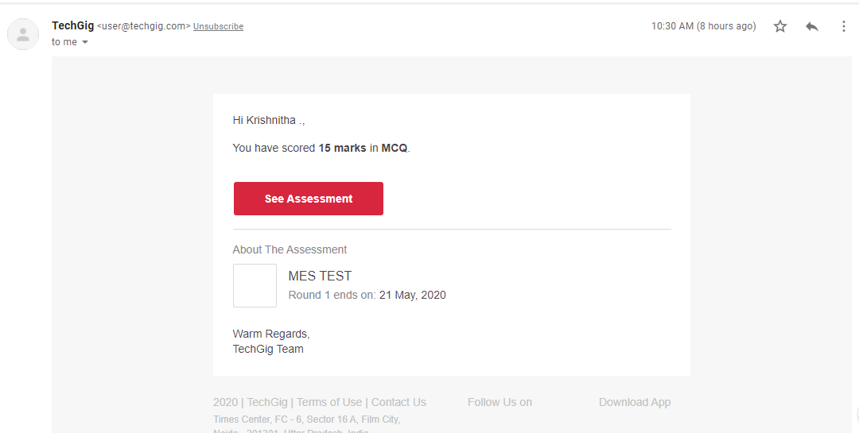

Certification Course Details:

Today I have done STEPathon-communication skills certification course. This course is on communication skills. Today I have completed third week of the course consisting of 9 videos. There were assessment’s related to our listening, Reading, Writing and Grammar skills.

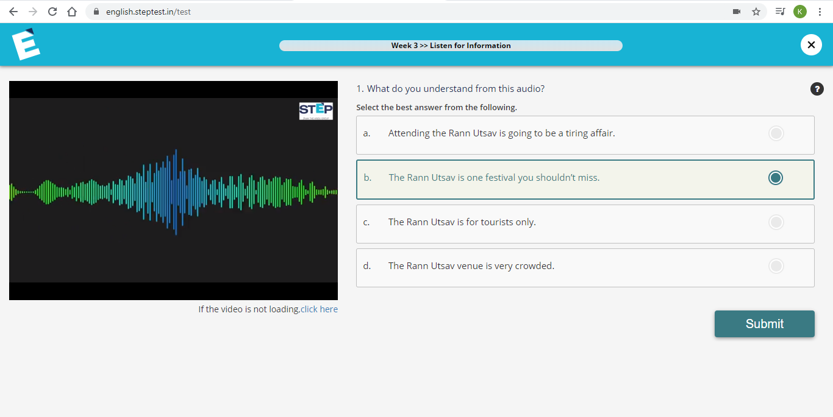



Coding Challenges Details:

Problem 1: Write a C program to implement SRTF process scheduling.  
Input: A set of processes with their burst time and arrival time.  
**Output**: The processes scheduled based on the arrival time and a smaller burst time.

**Solution:** Uploaded it in GitHub

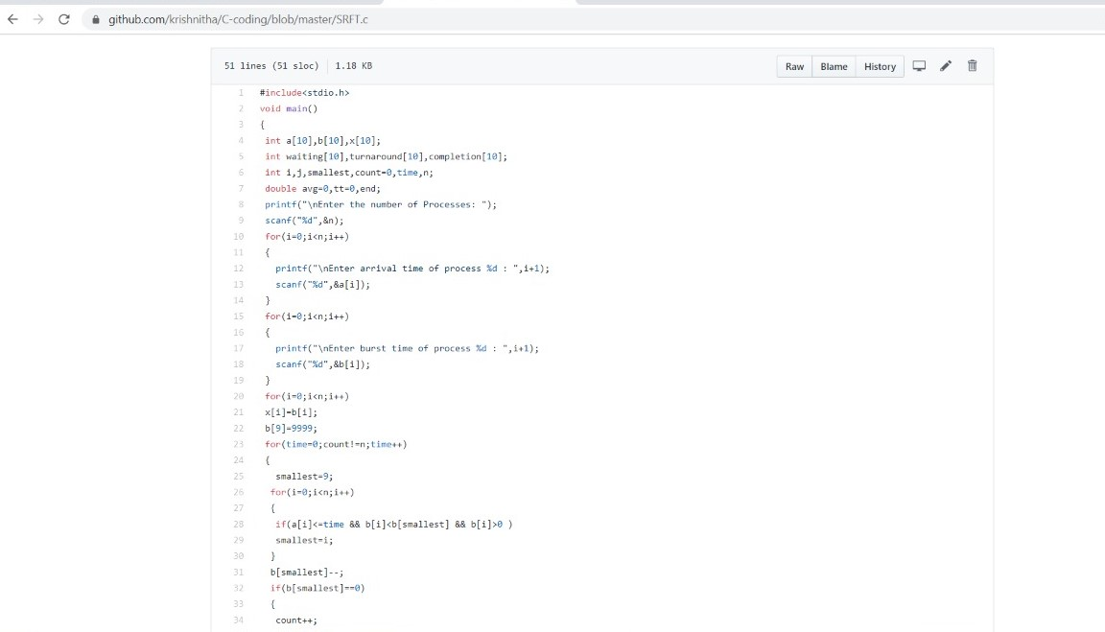

Problem 2: Write a C program to construct a singly linked list by removing duplicate elements in the sorted linked list

**Description:**

Take a sorted list and traverse the list. Compare the current node element with next adjacent node. If it is same then delete second element, if not retain. Finally print the resulting list.

**output:**

Given list {1,2,2,3,3,3,4}

Resulting list {1,2,3,4}

**Solution:** Uploaded it in GitHub

